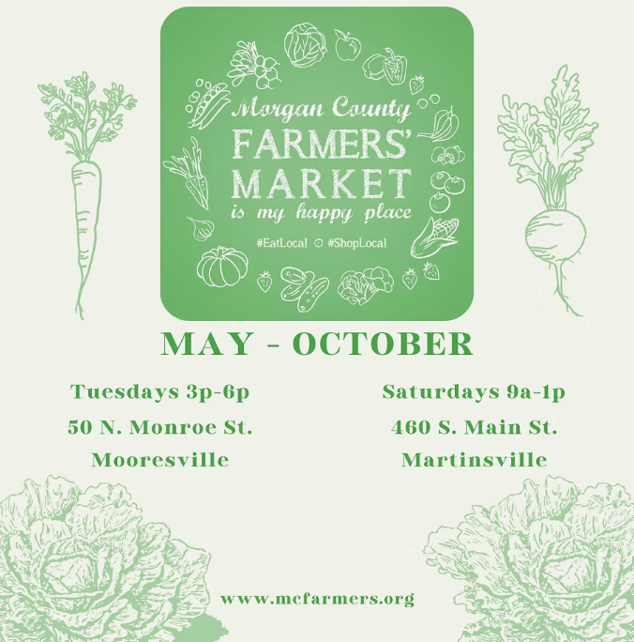

Your "Farm to Table" source for Morgan County, Indiana.
Mooresville - Martinsville
Morgan County Farmers Market Association

2026 Vendor Application
Circle One: Farmer/Grower Specialty Food Artisan/Crafter* Non-Profit Informational
*Artisan/Crafter vendors are subject to approval of the board. Please submit a product description with a photo and/or web page address to info@mcfarmers.org .
Contact Name: ___________________________________________________________________
Business/Farm Name: ___________________________________________________________
Address: ____________________________________________ County: ____________________
City: ______________________________ State: ___________ Zip Code: ___________________
Cell Phone: ________________________________E-mail: _______________________________
Social Media Handle(s): ___________________________________________________________ Please provide a copy of the Vendor License, if applicable.
TYPE | IDENTIFICATION NUMBER
Commercial Kitchen License
Egg Board License
ServSafe Food Handler
Other:

I plan to sell at the market: (check one)
___ $150 Season Pass → Circle one: Full payment Partial payment Defer payment
(You may choose to pay this fee in installments, but the full $150 must be paid in full no later than Saturday, June 7, 2025.) ___$80 Half Season Pass → Circle one: Full payment Partial payment Defer payment
___$100 Full Season one Market → Circle one: Full payment Partial payment
Defer payment
___ $25 Weekly Pass
(Weekly Pass includes vending at Mooresville & Martinsville markets in one fee. Payment is due weekly to Market Manager.)

An Association membership fee of $25.00 per year is required of all vendors in addition to booth fees. Please include membership fee with application. Make checks payable to Morgan County Farmers Market Association.

I acknowledge by my signature below that I have read the rules for the Morgan County Farmers Market Association and agree to abide by all the terms and conditions.

Signature______________________________________ Date: ______________________
P.O. Box 1121
Martinsville, IN 46151
Morgan County Farmers Market Association

Waiver of Liability & Photographic Release

I hereby waive, release, and agree to hold the Morgan County Farmers’ Market Association (herein as MCFMA) harmless for any injury or damages, medical or otherwise, suffered by myself or my dependent(s) while volunteering and or participating at a MCFMA event or activity.

I acknowledge that being present and participating at a MCFMA event or activity may involve certain risks of injury and bodily harm and agree to accept the risk of injury for myself and my dependent(s). I further acknowledge that I have read and examined this Waiver and fully understand its terms and have voluntarily executed the same.

I expressly agree that this Release is intended to be as broad and inclusive as permitted by the laws of the State of Indiana, and that this Release shall be governed by and interpreted in accordance with the laws of the State of Indiana.

I hereby grant and convey unto the Morgan County Farmers’ Market Association all right, title, and interest in any and all photographic images and video or audio recordings made by MCFMA during the activities with MCFMA, including, but not limited to, any royalties, proceeds, or other benefits derived from such photographs or recordings.

____________________________________ ___________________________
Signature of Volunteer / Participant Date

____________________________________
Printed name of Volunteer / Participant

If the volunteer/participant is under 18 years of age, a parent/guardian must also sign this waiver.

____________________________________ ____________________________
Signature of Parent / Guardian Date

Printed name of Parent / Guardian __________________________________

v.01.15.26

