1. PURPOSE
The primary purpose of the Morgan County Farmers Market Association (MCFMA) is to provide an attractive venue for consumers to purchase locally grown, fresh produce from local growers and producers. Along with this purpose, we have the following goals: to support and develop local farmers and growers, to enrich and educate the community by promoting a healthy lifestyle, and to provide a community activity that fosters social gathering and interaction within the municipal areas of Morgan County. MCFMA wishes to assist in vendor growth and success by utilizing available resources for success. MCFMA supports the USDA program Indiana Grown.

Unless specifically accepted by the Morgan County Farmers Market Association’s Board of Directors, “locally grown” is defined as having been started from seed or immature plant or created from plant or animal materials grown within the State of Indiana. Furthermore, a “local producer” is defined as a legal Indiana resident within a 75-mile radius of Centerton, Indiana.

2. MARKET LOCATIONS AND DATES
MCFMA operates at three distinct market locations throughout each year and are as follows:

MARTINSVILLE MARKETS:  The Main Connection Lawn  460 S Main St., Martinsville  Every Saturday, May 3 – October 25  9:00 AM – 1:00 PM | HOLIDAY MARKET:  Art Sanctuary (part of Cookie Stroll)  190 N. Sycamore St., Martinsville  December 13, 2025 (subject to change)

MOORESVILLE MARKETS:
Mooresville Friends Church
50 N Monroe St., Mooresville
Every Tuesday, May 6 – September 23
3:00 PM – 6:00 PM

3. MARKET MANAGEMENT
Market management will be implemented by members of MCFMA Board of Directors or their assignee to provide market oversight. The Market Manager will have authority over the operation of the market including vendor qualification, policies compliance, space assignment, and products sold. All vendors must check in with the Market Manager prior to setting up, including signing in with all required information and paying the appropriate space fee.

The Board may resolve any disputes and consider appeals based on the decisions of the Market Manager. Volunteers may be called upon to help with various tasks at the market, including providing information or collecting survey information at the market information booth space, help with setting up and tearing down at the market, and other miscellaneous tasks. Volunteers may not enforce policies at the market.

The MCFMA encourages brand/logo development from vendors. All brand/logo items need to be approved by the Market Manager. Let us help grow both our businesses successfully.

4. MARKET BOOTH SPACE, FEES, AND TIMES FOR SET UP AND TEAR DOWN
An Association membership fee of $25.00 per year is required of all vendors in addition to booth fees. Membership is open to any person or organization supporting or encouraging the ideals and purpose of the Association. Booth rental for the 2025 Season will be as follows:
May - December
- $25 Weekly Fee per booth space. This option gives vendors the ability to vend at both Mooresville and Martinsville in the same week for the price of $12.50 per market. A good option for those who plan to participate in fewer than 7 market weeks during the season.
- $150 Full Season Fee. This season fee provides access to all Mooresville and Martinsville markets in addition to the Holiday Market (total of 48 markets). Vendors may set up at all markets. Vendors may choose to pay this fee in installments, but the full $150 must be paid in full no later than Saturday, June 7,2025. Otherwise, weekly booth fees apply.
- $80 Half Season Fee. This half season fee provides access to all Mooresville and Martinsville markets between May 3, 2025 and July 26, 2025 or between August 2, 2025 and October 25, 2025 but it does not include the Holiday Market.
- $100 Full season one market fee. This season fee provides access to either the Martinsville or the Mooresville market individually for the entire season May 3, 2025 to October 25, 2025; but does not include the Holiday Market.
- All Half Season and One market Full season vendors may be put on a first come waitlist for the Holiday Market and pay a fee of $25 if there is room.

Checks must be made out to the Morgan County Farmers Market Association (MCFMA). If a check is returned for insufficient funds, an NSF Fee shall be assessed for $35.00. A new check or cash is to be provided within two weeks of being notified by the Manager to cover the returned check, plus the NSF fee. Three NSF events will be grounds for expulsion from the market.

At the Martinsville location, vendors must check in no earlier than 8:00 a.m. to sign in, pay any fees, display season passes, and verify/receive booth space assignments. At the Mooresville location, vendors must check in no earlier than 2:00 p.m. for the same items. The Market Manager may utilize other methods for coordinating booth assignments at his/her discretion.

Martinsville Market Layout
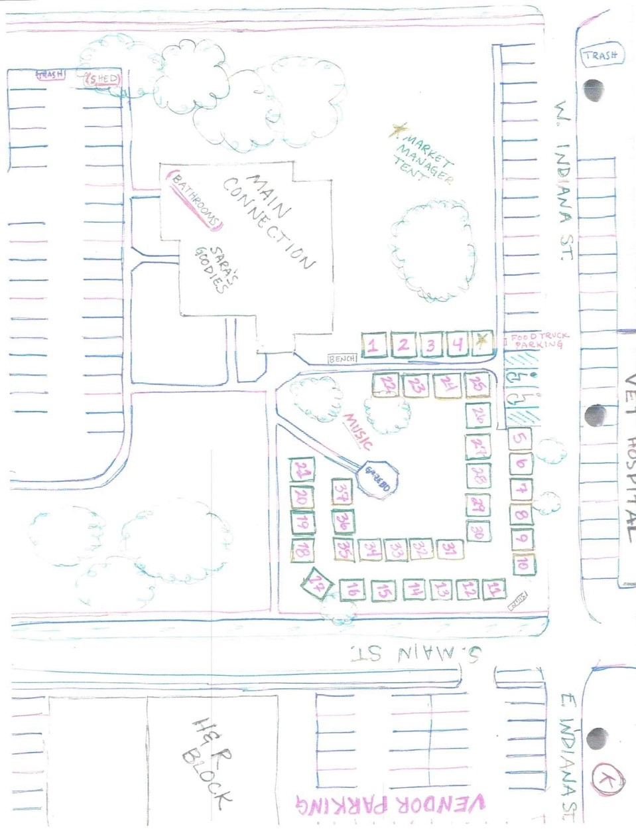

Mooresville Market Layout
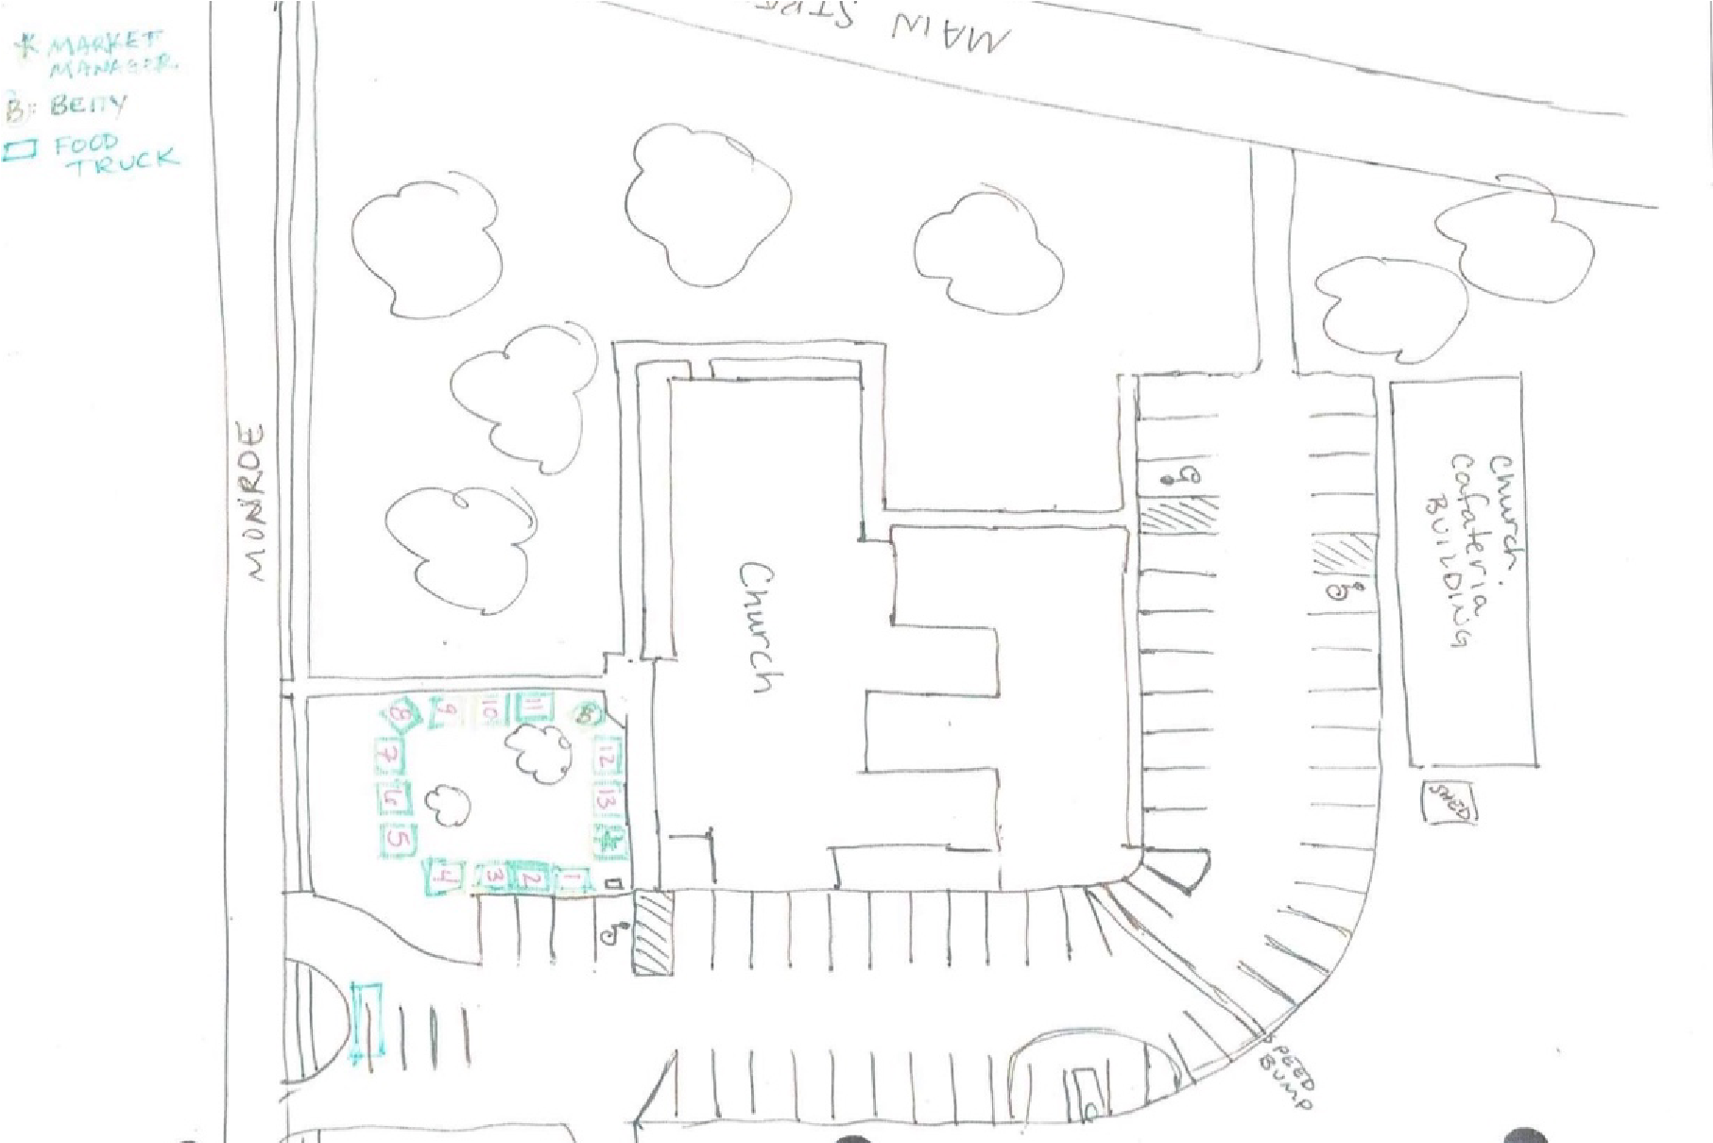

5. GROWERS / PRODUCERS VENDORS PERMITTED WARES
Vendors must have grown their produce and/or created and/or produced all other items that are offered for sale. If operating as a “home-based vendor”, review updated Indiana Code 16-42-5.2 passed under Indiana’s House Enrolled Act 1149.

Value added items such as jams, jellies, dried fruits and vegetables, frozen meat, frozen fish, and dairy products are allowed if at least 50% of the raw ingredients that are available within the state of Indiana. Foods (except for meats, including beef, pork, fish, and poultry) must be prepared by the vendor in a manner consistent with standards set forth by Indiana IC 16-42-5.3 and have labeling that gives the name of the product, the location of preparation (including contact information of the producer), the contents, the overall weight, and the price. The vendor must provide a copy of all licenses and permits as well as a list of ingredients for value added foods to the Manager to verify that the above guidelines are met, or they must provide a letter from the Morgan County Health Department stating permissibility of the item for retail sale. Vendors must display documentation for all permits and licenses at their space in a manner that is clearly visible to the public.

Baked goods and soaps are permissible to sell. Value-added foods that are prepared at the market (for example, cooked meat, popcorn made on site, etc.) will be allowed in 2025 to a limited number of applicants and display the required permit(s). Please check with the Manager to find out more information.

The sale of any non-vendor produced items are prohibited, apart from branded merchandise intended to advertise vendor branding (subject to approval). Items of any sort that are deemed by the manager to be of poor taste or quality will not be allowed.

6. ARTISAN / CRAFTER VENDORS PERMITTED WARES
To support local artisans and craftsmen and to provide more interest in our market, the Board permits the sale of personally handmade locally produced artwork / craft. Examples of possible crafts are jewelry, wreaths, floral displays, woven items, handcrafted textiles, and carved wooden products. To qualify, a majority of the tools and equipment used by the crafter must require skills, personal handling and crafter guidance. Work should be made by hand and show imagination, skill, and the mark of individuality. The Market Manager has total authority to determine all products sold/represented in the market. To assure quality art/crafts at the market all items may be juried by the Board of Directors. Items made from kits or mechanically mass produced are not acceptable.

7. VENDOR TERMS
Goods must be displayed and sold from a tented, canopied, booth. For the safety of all market participants, you must have appropriate weights for your canopy at least 15# per leg of your canopy. Vendors must furnish their own tent, tables, chairs, and other display arrangements. Vendors are limited to the area (approx. 10’ x 10’) for which they have paid. Shelter, coats, and hats will not be provided in inclement weather. Vendors will provide their own shelter and weather attire.

Regarding produce and item pricing, vendors should consider quality and supply. It is suggested that vendors reference area store / market prices. The Market Manager is not responsible for settling price disputes between vendors.

Vendors must keep their produce in good condition. Low quality or dirty vegetables, fruits, and other items, as determined by the Manager, must not be displayed, or sold.

At the Martinsville location, vendors will have their booth in place by 8:45 a.m. and they must have their stand set up completely by 9:00 a.m. At the Mooresville location vendors must have their vehicle / booth in place by 2:45 p.m. and their stand set up completely by 3:00 p.m. Vendors must stay at their booths, without packing up, until the ending time of the market (1:00 p.m. in Martinsville and 6:00 p.m. in Mooresville). Vendors must NOT tear down their displays before the ending time on each market day; except in unusual circumstances as determined by the Market Manager.

To encourage customers to come back, vendors are recommended to engage market goers (customers will likely ignore booths where the vendors are reading books, talking on cell phones, playing electronic games, or are otherwise not engaging).

Please note: Out of respect for the venues which host our markets, NO VEHICLES are allowed on the grass at ANY TIME at either venue. Please plan accordingly when parking to load/unload your vehicle. During operating hours, vendors and customers are required to park at the H&R Block lot across Main Street from the market. This is subject to change during the season as priorities of our host locations may change.

Martinsville vendors: DO NOT PARK AT THE ANIMAL HOSPITAL AT ANY TIME.
For certain vendors, the Market Manager may allow parking in The Main Connection’s North lot during operating hours of the Martinsville market. This allowance may be made ONLY by preapproval of the Manager. If you are a vendor with particular interest in a parking lot booth space, please apply for approval before the next market day.

Vendors will not produce noises or fumes that are potentially disturbing to customers or other vendors. Vendors will not smoke in the market or within one block of the market.

8. NONPROFIT ORGANIZATIONS
As stated in Section 1, Purpose, MCFMA markets are a resource to the local communities for local food and a venue to foster community interaction. We welcome area non-profits to utilize the markets for community outreach. All organizations MUST contact MCFMA for prior approval to participate in a market and be instructed in market requirements. Organizations WILL NOT be allowed to just show up the day of the market and participate.

Non-profits will be allowed to sell memberships, tickets to upcoming events but WILL NOT be allowed to distribute food, for sale or for free, or any items that compete with market vendors. All non-profits must become members of the Association ($25 annually) and abide by all market policies. No booth or season pass fees apply to NFPs. Acceptance to participate in the market is at the sole discretion of the Board of Directors as to the organization’s relevance to MCFMA stated purposes.

9. HEALTH AND SAFETY REQUIREMENTS AND REGULATIONS
All items intended for human consumption must be always kept at least 6 inches off the ground, be under a tent or umbrella, and be in a safe and sound condition. Vendors are responsible for any damages resulting from the sale of unsafe or unsound goods. All items must meet state, county, and local health requirements, policies, and regulations. Potentially hazardous foods will ONLY be allowed to be sold as produced and permitted by applicable law. For reference, please contact the Morgan County Health Department at (765) 342-6621.

Permits for consumable goods must be visible at the market. All items requiring immediate refrigeration must meet state, county, and local health requirements, policies, and regulations. Vendors are responsible for their own refrigeration source. Vendors are responsible for complying with all applicable laws, regulations, and ordinances pertaining to their products.

Tents must be fastened down with heavy-duty weights, per manufacturer's guidelines, no matter what the weather. In the case of lightning and dangerous weather vendors are encouraged to leave their vendor space and saleable goods to seek safety. Please do not risk your life to save the items that you have for sale! Refer to the MCFMA Weather Policy for additional information.

The markets are conducted in a manner to promote a publicly safe, social, and friendly atmosphere; to that end NO open-carry firearms are permitted and those vendors with legal concealed-carry permits MUST maintain their concealment.

Additionally, the markets will be maintained as a drug free area. For health and safety reasons vendors must not bring pets or other live animals to the market except for service animals. Service by the animal must be for something other than providing emotional well-being. The Manager reserves the right to ask that the animal undergo additional training or be removed from the market if the animal appears ill or if it has become disruptive.

Vendors will not dump grease, oil, or liquids in the market area. Waste must not be put into dumpsters that are near the market location. Instead, waste must be packed out by each vendor.

Failure to completely clean up assigned spaces and surrounding area may result in loss of vendor privileges or a fine of $100.00 payable to the MCFMA.

10. COVENANT NOT TO SUE
By participating in the market, the vendor agrees not to institute any action or suit of law or inequity against the MCFMA, its employees, volunteers, agents, officers, and designees because of action taken under this contract. The vendors will not aid in the institution or prosecution of any claims for damages, costs, loss of services, expenses, or compensation for or on account of any damages, loss or injury to person or property resulting from the terms of vendor’s participation in the market.

11. INDEMNIFICATION
The Vendor hereby agrees to indemnify, hold harmless, release, waive, and forever discharge MCFMA’s employees, volunteers, agents, officers, and designees from all actions, damages, liabilities, and expenses, including reasonable attorney fees and court costs that may arise out of or as a result of the Vendor participating in the market.
All vendors must have a signed liability and photographic waiver on file with MCFMA.

12. INSURANCE
The MCFMA Board of Directors strongly suggests that the vendor shall have liability insurance for protection against damages in the event injury occurs at the Market or an injury is caused by their products.

13. THE FARMERS MARKET NUTRITION PROGRAM
The MCFMA believes that it is intrinsic to the purpose of the organization to support, promote, and foster an environment that increases access to locally grown produce. However, due to recent changes at the Federal, State, and Local levels of Government, the MCFMA is taking steps to be able to participate as a market within the MarketLink and WIC programs. The MCFMA supports these programs through annual budgeting, and the MCFMA strongly encourage vendors to become approved vendors through the Indiana Department of Health for both the WIC Farmers’
Market Nutrition Program (FMNP) and the Senior Farmers’ Market Nutrition Program (SFMNP).
For more information on these programs contact the MarketLink and WIC program coordinators.

14. MARKET PRODUCT VIOLATION
If the Manager finds that a product being offered by a vendor does not adhere to the policies and practices of the MCFMA, the following process shall be observed.
- Verbal warning and inspection is given by the Market Manager within five days. The Market Manager will make an appointment with the vendor within this time frame. The vendor will allow the Market Manager on his or her personal property for an inspection of growing and production areas.
- A timely inspection is held by the Market Manager and if a violation is found, it will result in the product being excluded from the market for the season. If a timely inspection is refused it will result in the expulsion of the vendor from the market for the season.
- If a vendor allows an inspection and is found guilty of a product violation and receives a second product violation within the same season, he or she will be expelled from the market for the rest of the season.
- If the case is not resolved with the Market Manager, the vendor may appeal to the MCFMA Board. The decision of the Board is final.
- Vendors may not add products of different categories (e.g.. farmer/growers selling baked goods or jewelry makers selling produce) without prior approval from the market manager.

15. COMPLAINT PROCEDURE
If a vendor complaint is received to the Market Manager a formal investigation and report will be made. The Board will be notified. The Market Manager has the authority to impose fines up to $100 to either/both parties concerned. MCFMA always encourages a professional respectful selling atmosphere to the public.

16. VENDOR VIOLATION PROCEDURE
If a vendor is found to be in violation of one or more of the above market policies, the following process shall be observed.
- Market policy violation noted by the Market Manager
- Verbal warning issued by the Market Manager and noted to the Board
- Written warning issued by the Market Manager (with signature of the vendor) and suspension of the vendor pending review from the Board
- Expulsion from market for the season
- Appeal to the Board. The Board determines if the vendor will be expelled for the season or not. Decision of the Board is final.

17. MCFMA WEATHER POLICY (Feb 2025)
Weather in Central Indiana can be tricky to predict and is ever changing. The MCFMA Board of Directors entrusts the Market Manager to make weather related decision given the best available weather information at the time of the decision with the assistance of available board members present at the market. A passing shower or downpour does not constitute a closing of the market; however, the presentation of impending serious weather requires a decision to 1. Delay opening,
2. Cancel the market day or 3. Close the market early.

If weather is such that at least a half market day cannot be achieved, a decision will likely be made to cancel the market. This is the last resort. If the Market Manager determines to cancel the market, notice must be given to the vendors a minimum of thirty minutes prior to closing.

The Market Manager should consult those who have reliable weather apps by smart phone or similar resources, but the Market Manager must also use common sense to access the situation and must decide and notify all concerned. This includes posting on Facebook (Market page and the Vendor Group page).

If a decision to close the market is made, no vendor has the option of staying. They do not have permission to use the location without MCFMA presence.

Morgan County Farmers Market Association

2025 Vendor Application
Circle One:
Farmer/Grower Specialty Food Artisan/Crafter* Non-Profit Informational
*Artisan/Crafter vendors are subject to approval of the board. Please submit a product description with a photo and/or web page address to info@mcfarmers.org .
Contact Name: ___________________________________________________________________
Business/Farm Name: _____________________________________________________________
Address: ____________________________________________ County: ____________________
City: ______________________________ State: ___________ Zip Code: ___________________
Cell Phone: ________________________________ E-mail: _______________________________
Social Media Handle(s): ___________________________________________________________ Please provide a copy of the Vendor License, if applicable.
TYPE | IDENTIFICATION NUMBER
Commercial Kitchen License
Egg Board License
ServSafe Food Handler
Other:
I plan to sell at the market: (check one)
___ $150 Season Pass → Circle one: Full payment Partial payment Defer payment
(You may choose to pay this fee in installments, but the full $150 must be paid in full no later than Saturday, June 7, 2025.) ___$80 Half Season Pass → Circle one: Full payment Partial payment Defer payment
___$100 Full Season on Market → Circle one: Full payment Partial payment Defer payment
___ $25 Weekly Pass
(Weekly Pass includes vending at Mooresville & Martinsville markets in one fee. Payment is due weekly to Market Manager.)
An Association membership fee of $25.00 per year is required of all vendors in addition to booth fees. Please include membership fee with application. Make checks payable to Morgan County Farmers Market Association.

I acknowledge by my signature below that I have read the rules for the Morgan County Farmers Market Association and agree to abide by all the terms and conditions.

Signature______________________________________ Date: ______________________
P.O. Box 1121
Martinsville, IN 46151
Morgan County Farmers Market Association

Waiver of Liability & Photographic Release

I hereby waive, release and agree to hold the Morgan County Farmers’ Market Association (herein as MCFMA) harmless for any injury or damages, medical or otherwise, suffered by myself or my dependent(s) while volunteering and or participating at a MCFMA event or activity.

I acknowledge that being present and participating at a MCFMA event or activity may involve certain risks of injury and bodily harm and agree to accept the risk of injury for myself and my dependent(s). I further acknowledge that I have read and examined this Waiver and fully understand its terms and have voluntarily executed the same.

I expressly agree that this Release is intended to be as broad and inclusive as permitted by the laws of the State of Indiana, and that this Release shall be governed by and interpreted in accordance with the laws of the State of Indiana.

I hereby grant and convey unto the Morgan County Farmers’ Market Association all right, title, and interest in any and all photographic images and video or audio recordings made by MCFMA during the activities with MCFMA, including, but not limited to, any royalties, proceeds, or other benefits derived from such photographs or recordings.

____________________________________ ___________________________
Signature of Volunteer / Participant Date

____________________________________
Printed name of Volunteer / Participant
If volunteer / participant is younger than 18 years old, a parent/guardian must also sign this waiver.

____________________________________ ____________________________
Signature of Parent / Guardian Date

____________________________________ Printed name of Parent / Guardian v.02.15.24

